**Task 3: Backup Configuration for Web Servers**

**Objective**

Automate weekly backups of Apache (Sarah) and Nginx (Mike) configuration and content directories, saving them securely with proper logging and integrity verification.

**Step 1: Create Backup Directory**



**Step 2: Create Backup Scripts**

For Sarah (Apache Backup Script)

Create backup script



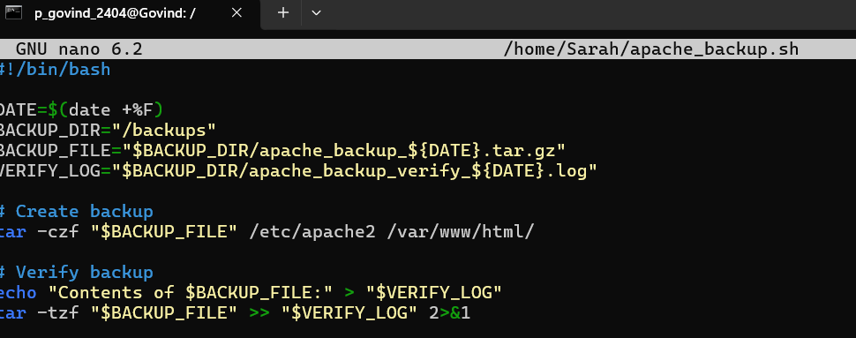

Make it executable:



For Mike (Nginx Backup Script)



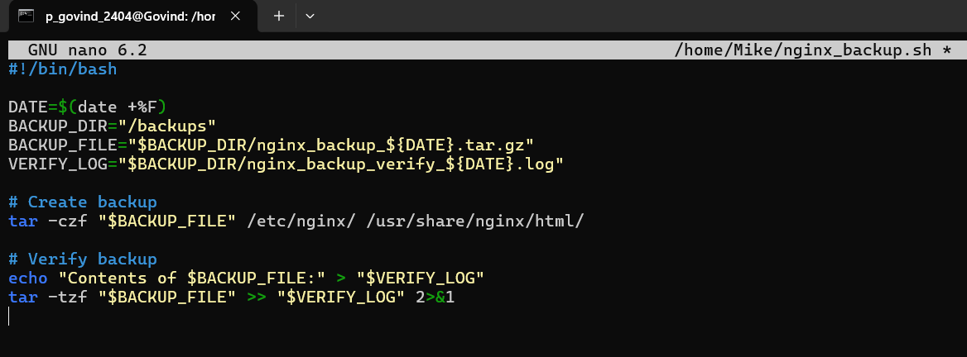

Make it executable:



**Step 3: Test the Scripts Manually**





**Backup files are created:**



**Step 4: Schedule Cron Jobs (Every Tuesday @ 12:00 AM)**

